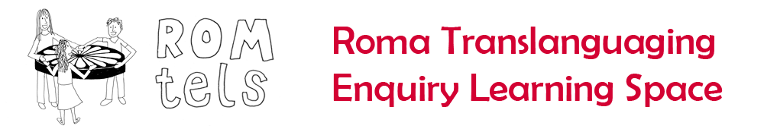

Languages for Dignity: Translanguaging in Newcastle

What could this mean for your own context?

* What did you think of the technology?
* What did you think of the enquiries?
* What did you think of the dual language presentation?
* What did you think of the children’s use of languages?